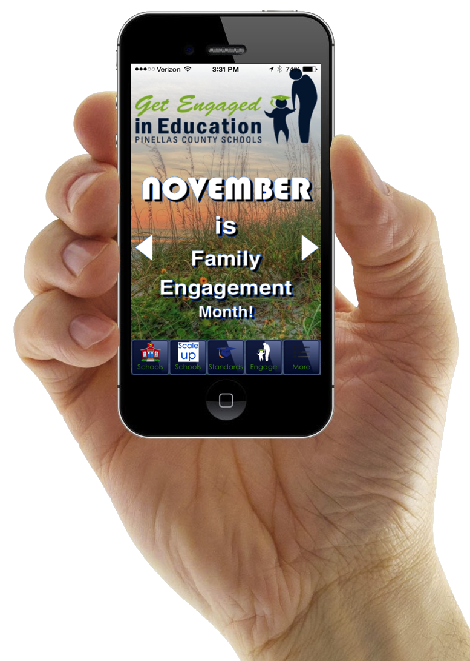**HOME SCREEN - ICONS**

What can I find on the PCS Family Engagement Mobile APP?

* **Schools**
  + Listing of all schools that links directly to their website
* **Scale up Success Schools** (For those schools only)
  + Websites
* **Florida Standards** – Change from FCAT to Florida Standards
* **Get Engaged** – Daily Tips, Family Resources,
  + Opportunities to volunteer – mentoring workshops, volunteer registration
  + Daily Tips for families
  + Family Resources –Family First, 2-1-1, Clothes to Kids, JWB Resources
* **More** – Important information for parents

**MORE –HIGHLIGHTS**

* **Messages** – the district can push messages to parents directly to their phones.

These messages will alert parents to upcoming events, weather alerts,

parent meeting notifications, etc.

* **Videos** – Parent Tips
* **Academic Support**
  + Beyond the Classroom
    - Learn To Type
    - ST Math
    - Ticket to Read
    - Brain POP
    - InSync
  + Kahn Academy
    - Math
    - Algebra
  + Florida Standards
    - Students and Parents Information
    - Practice Test for all grade levels – Writing, Reading, and Math
* **Parent Portal Login**
  + Access to student performance
  + Login for volunteer hours
* **Magnet Information**
  + District Application Programs Guide
* **Parent Academy Workshops**
* **Parent Advocacy**

**DOWNLOAD OUR PCS FAMILY ENGAGEMENT MOBILE APP ON EITHER APP STORE VIA THE LINKS BELOW OR TYPE IN “PCS FAMILY ENGAGEMENT”**

******Apple Store:** <https://itunes.apple.com/us/app/pcs-family-engagement/id928649586?ls=1&mt=8> **Play Store:** <https://play.google.com/store/apps/details?id=com.app_getengaged.layout>